**ASL RecogSys**

American Sign Language Recognition System (ASL RecogSys) is a graphical user interface (GUI) that is used in our major project “Real Time Sign Language Recognition and Speech Generation” as the interactive unit that helps the user to perform sign language recognition and text/speech generation as an output. This application uses tkinter python module for the graphical user interface.

1. **Start Page:**

This page has a complete name of the application. There are three buttons in this window.

1. **To Main Menu:** This button takes us to the main menu of this program where all the options/features that this app has, is provided.
2. **Help:** This button would open this file, which contains detailed information about this application.
3. 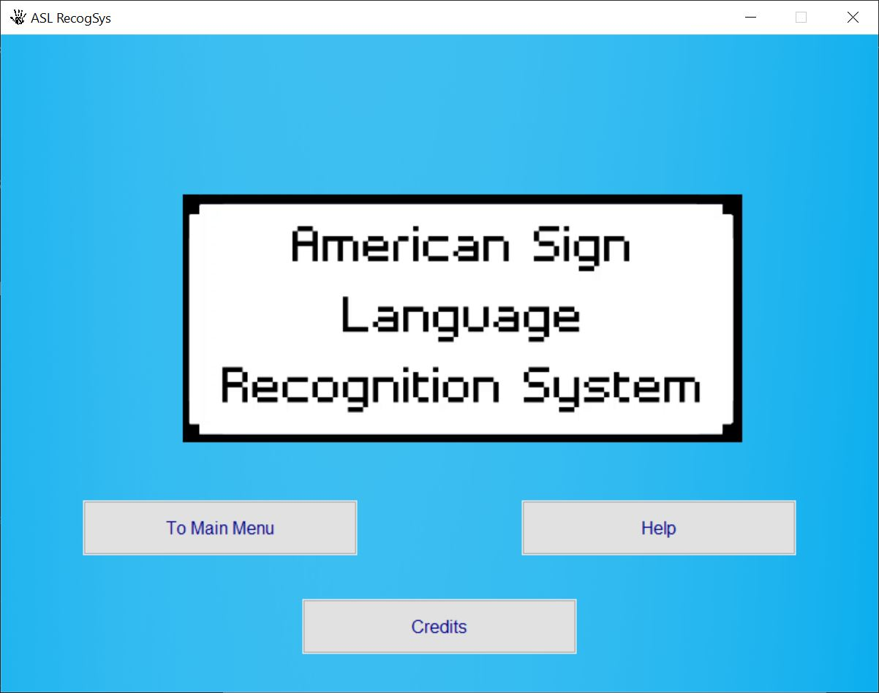**Credits:** This button would take us to the window where all the people related to the project are credited, with acknowledgement to the user.

Figure 1: Start Page of ASL RecogSys

* 1. **Main Menu:**

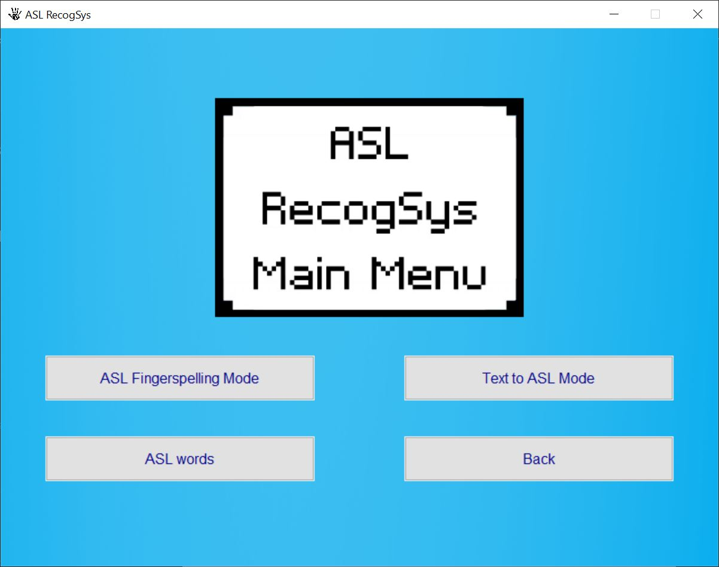This window contains the features that are available in the system. There are four buttons and they are:

Figure 2: Main Menu of ASL RecogSys

* 1. **ASL Fingerspelling Mode:**

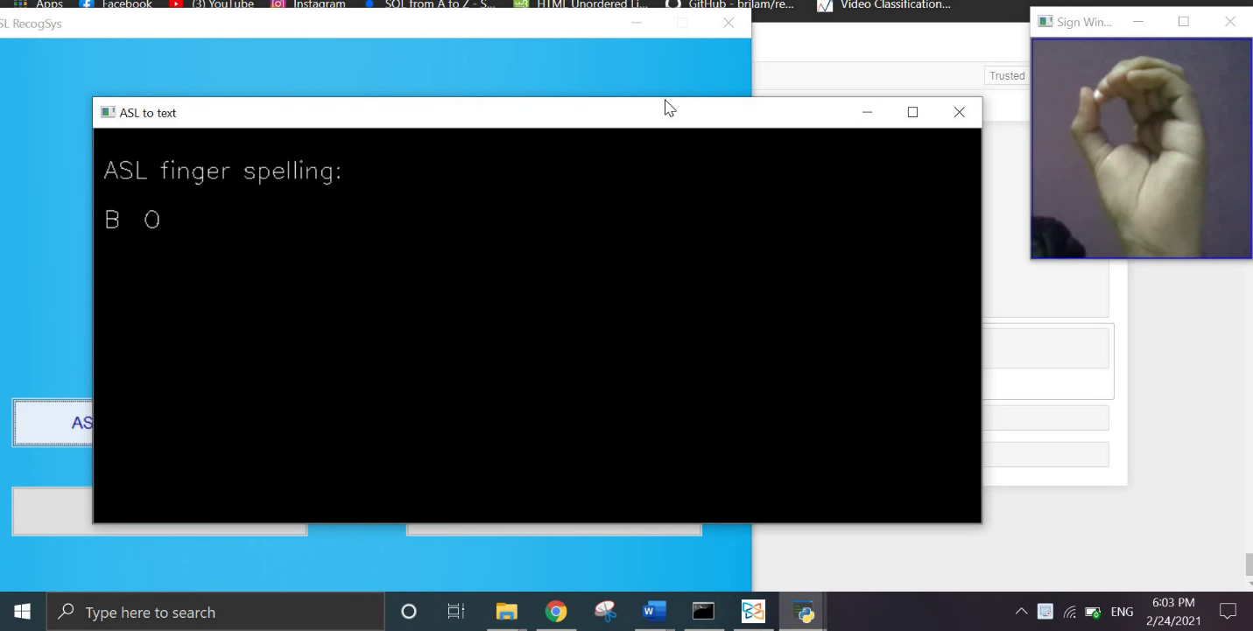In this mode, we can classify signs for alphabets from A-Z and space sign. After clicking this button, we will get Sign Window where the user can sign any of the alphabets from A-Z and then press <space> key to start classifying. The image is captured every five seconds and the classification is done continuously. The classified alphabet is also pronounced by the system in real time. To exit the system, press <q> key on the keyboard.

Figure 3: Sign Window

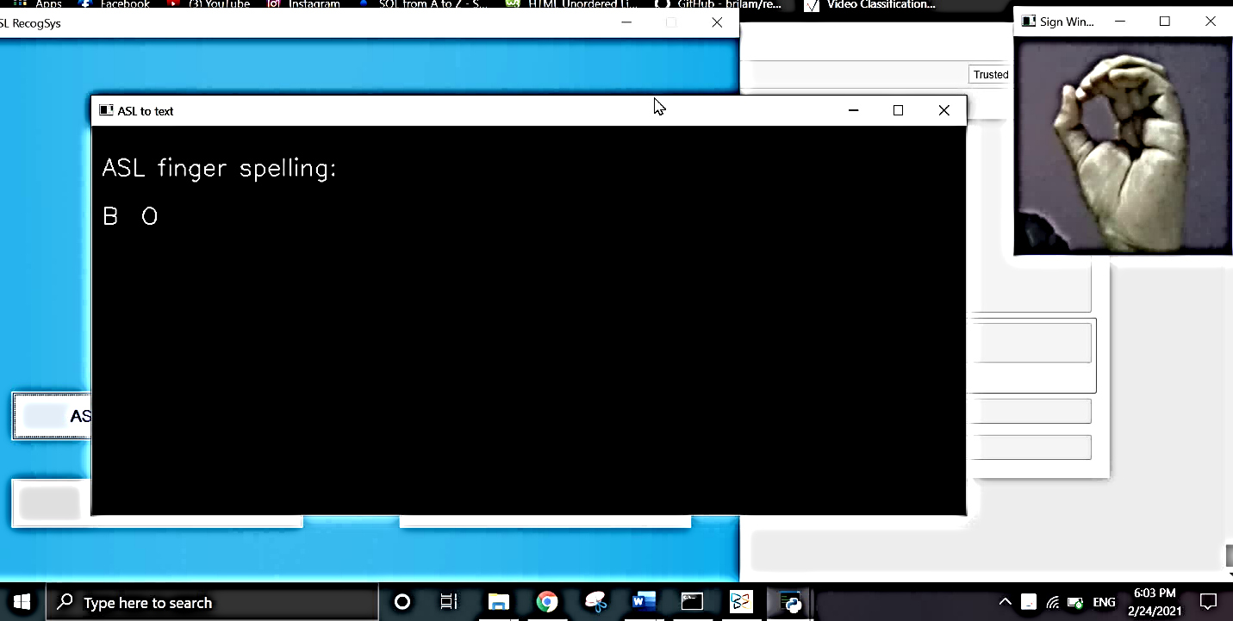

Figure 4: Output window for ASL Fingerspelling mode

* 1. **Text to ASL Mode:**

In this mode, we can generate ASL alphabet gif by entering a text in the Text Box. Enter any text in the text box and press <Okay> button. Then a gif is generated that has ASL alphabet images representing each letter of the text entered. Press <q> key on the keyboard to quit.

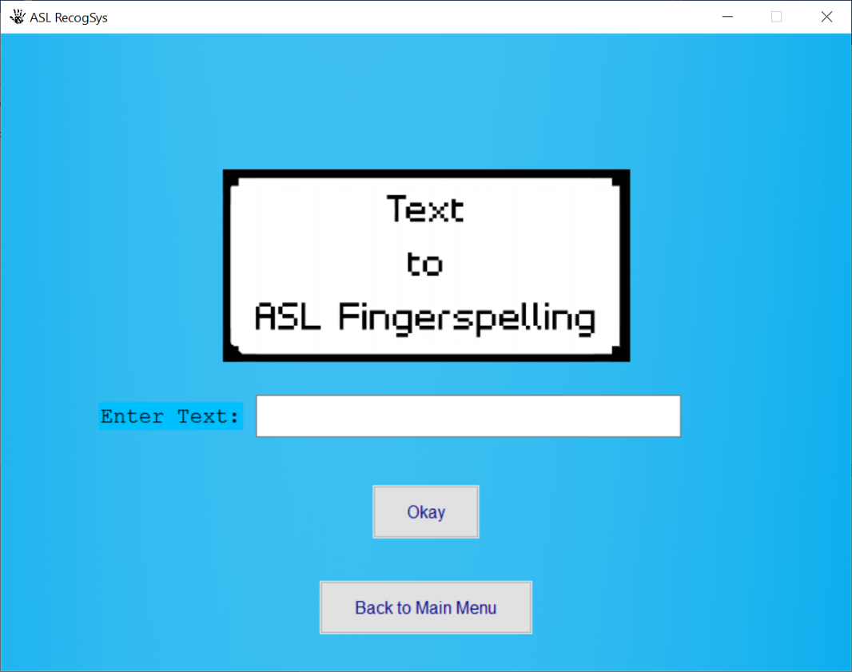

Figure 5: Text to ASL mode

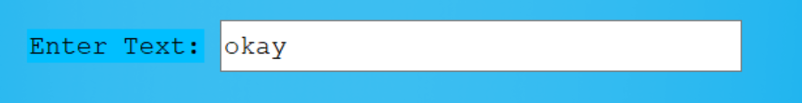

Figure 6: Text input

Figure 7: GIF generated

* 1. **ASL words:**

In this mode, there are five ASL words which are recorded as a video file in .avi format. After clicking this button, a window appears asking the user to press <space> key to start recording a two-second video. The user can press <q> key on the keyboard to quit. After that, the classification is done and the system generates speech for the classified category.

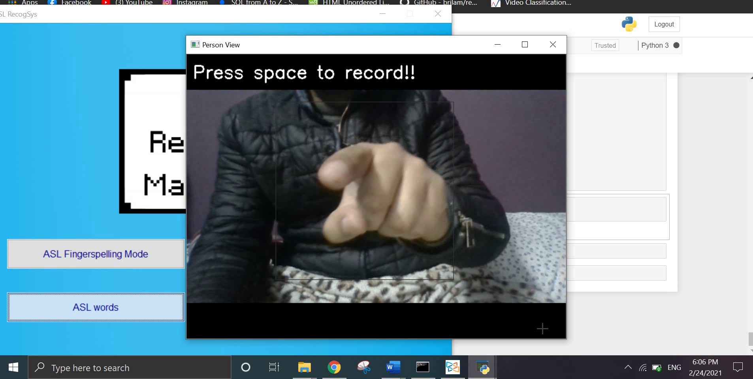

Figure 8: Recording video in ASL words mode

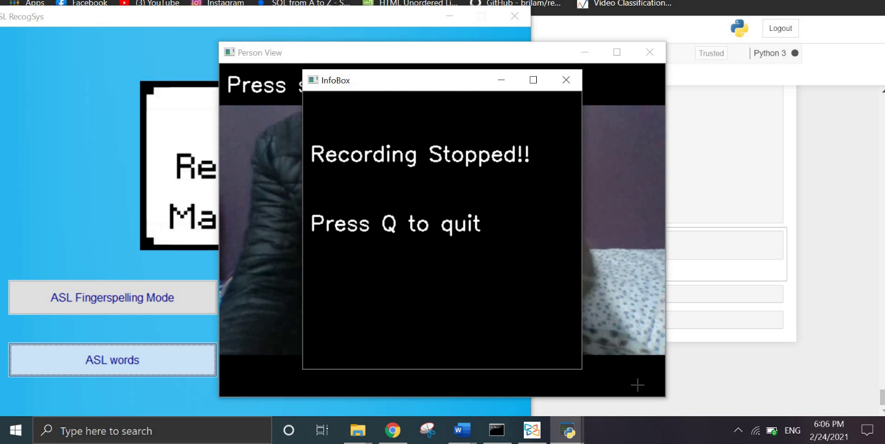

Figure 9: System providing information about stopping the recording

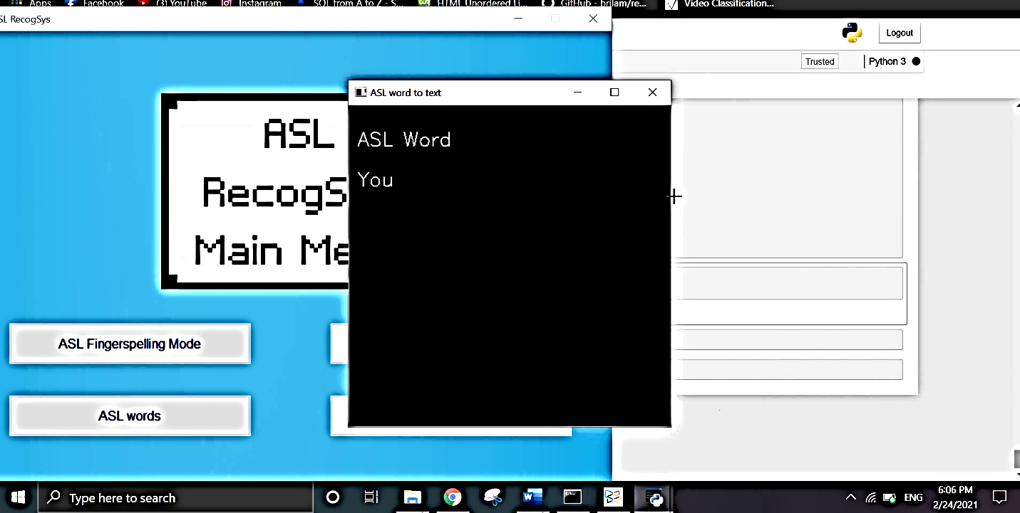

Figure 10: Output window for ASL words mode

* 1. **Back:** Return to the Main Menu

1. **Help:**

The Help Button will open the pdf file which has the information about the application on the user’s laptop.

1. **Credits:**

Credits window contains the contributors related to this project.

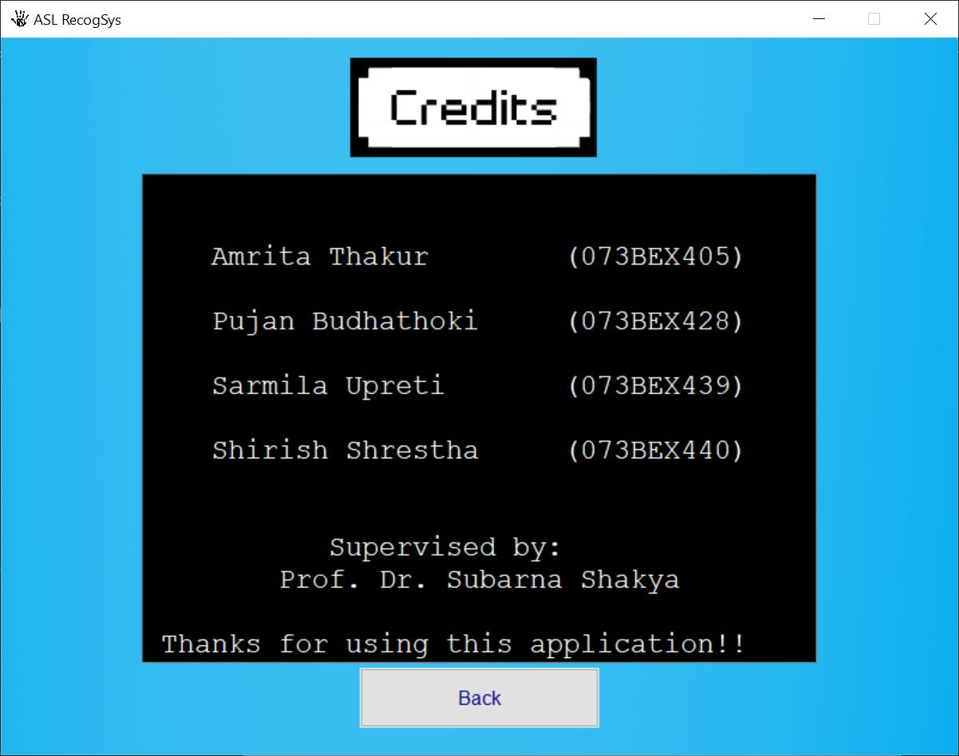

Figure 11: Credits

1. 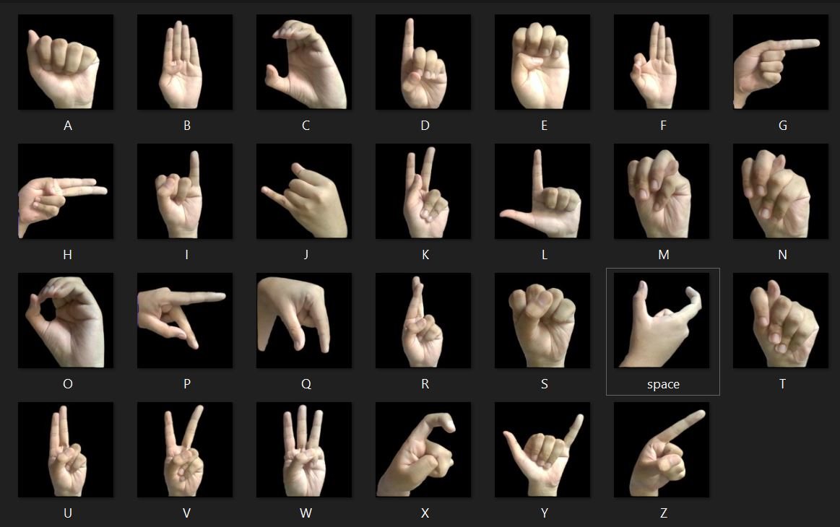**More Information:**



Figure 12: ASL alphabets used in ASL Fingerspelling Model

Figure 13: ASL word: Bye



Figure 14: ASL Word: Yes



Figure 15: ASL Word: Me





Figure 16: ASL Word: You

Figure 17: ASL Word: No